**The title of your contribution to SMCBS'2025**

**Piyush Sindhu Sharma1,†, Mihai Suster2, Włodzimierz Kutner1**

1Institute of Physical Chemistry, Polish Academy of Sciences, Kasprzaka 44/52, 01-224, Warszawa, Poland

2Candela Foundation, Grochowska 357 m. 513, 03-822 Warszawa, Poland

**†** corresponding author’s email: [cmcbs@ichf.edu.pl](mailto:cmcbs@ichf.edu.pl)

Please follow these rules to ensure the happiness of the organizers and the beauty of the book of abstract:

* write your abstract in Times New Roman 11pt,
* underline name of the presenting author,
* indent the first line of each paragraph,
* do not exceed **1 page,**
* include figures in the text with max. 2MB size,
* write the caption outside the figure frame (see Figure 1 as an example),
* insert your references and cite as [1] and [2],
* submit your abstract following procedure described at [www.smcbs.pl](http://www.smcbs.pl/)

We cordially invite researchers to participate in the 12th International Workshop on Surface Modification for Chemical and Biochemical Sensing, an interdisciplinary forum dedicated to advancing the understanding and application of surface science and technology. The workshop will feature presentations on a diverse array of topics, including chemo- and biosensing, chemical and biochemical surface modification, polymer film coating, inorganic, organic, and biomaterials for catalysis, electric energy generation, and storage, charge transport in surface films, novel techniques and instrumentation for surface examination, signal transduction and processing, detection techniques and protocols, system miniaturization, and nanotechnology use. This workshop provides a unique opportunity for experts from various disciplines to share their research findings, engage in meaningful discussions, and foster collaborations!

Join us at the SMCBS'2025 Workshop to explore the latest developments and future directions in this dynamic field.

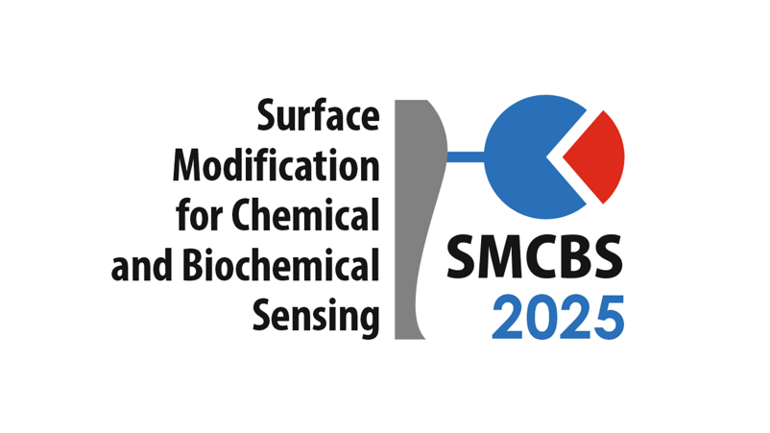

Figure 1: Caption of your figure: Times New Roman, 11 points.

Acknowledgments

Your acknowledgment text goes here.

**References**

1. N. White and G. Black*, Nature Materials* **6**, 9 (2024).
2. F. Bennett, X.Y. Harrison, and F. Foster, *Optica* **15**, 11220 (2023).